**Project 5**

**Launching the website using Load Balancer DNS name**

**VPC:**

Steps:

1. In AWS console, search VPC.
2. In VPC dashboard, you will get my VPC’s and click on myvpc’s.
3. Click on create VPC. Select resource to create as vpc only.
4. Give name as anu-vpc and IPv4 CIDR as 10.0.0.0/16.
5. Then click on create VPC.

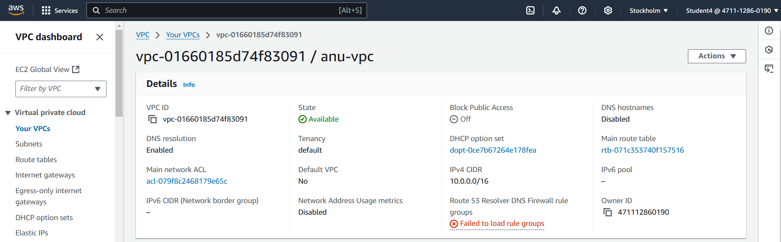

**Internet gateway:**

Steps:

1. In VPC dashboard, click on Internet Gateway.
2. To create Internet gateway, click on create Internet Gateway.
3. Then give name as Anu-igw and click on create Internet Gateway.
4. Your internet Gateway is created and attach it to vpc by clicking on action, attach to vpc.

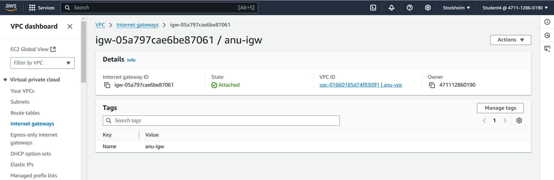

**Subnets:**

Steps:

1. To create subnet, go to VPC dashboard under virtual private cloud, click on subnet.
2. Select the vpc you have already created and in subnet setting, give subnet name as public-subnet-01, public-subnet-01, private-subnet-03 and private-subnet-04.
3. Then choose availability zone as region you have selected before creating the vpc and IPv4 subnet CIDR block as 10.0.1.0/25, 10.0.2.0/25, 10.0.3.0/25 and 10.0.4.0/25.
4. Then click create subnet. Your subnets are created.

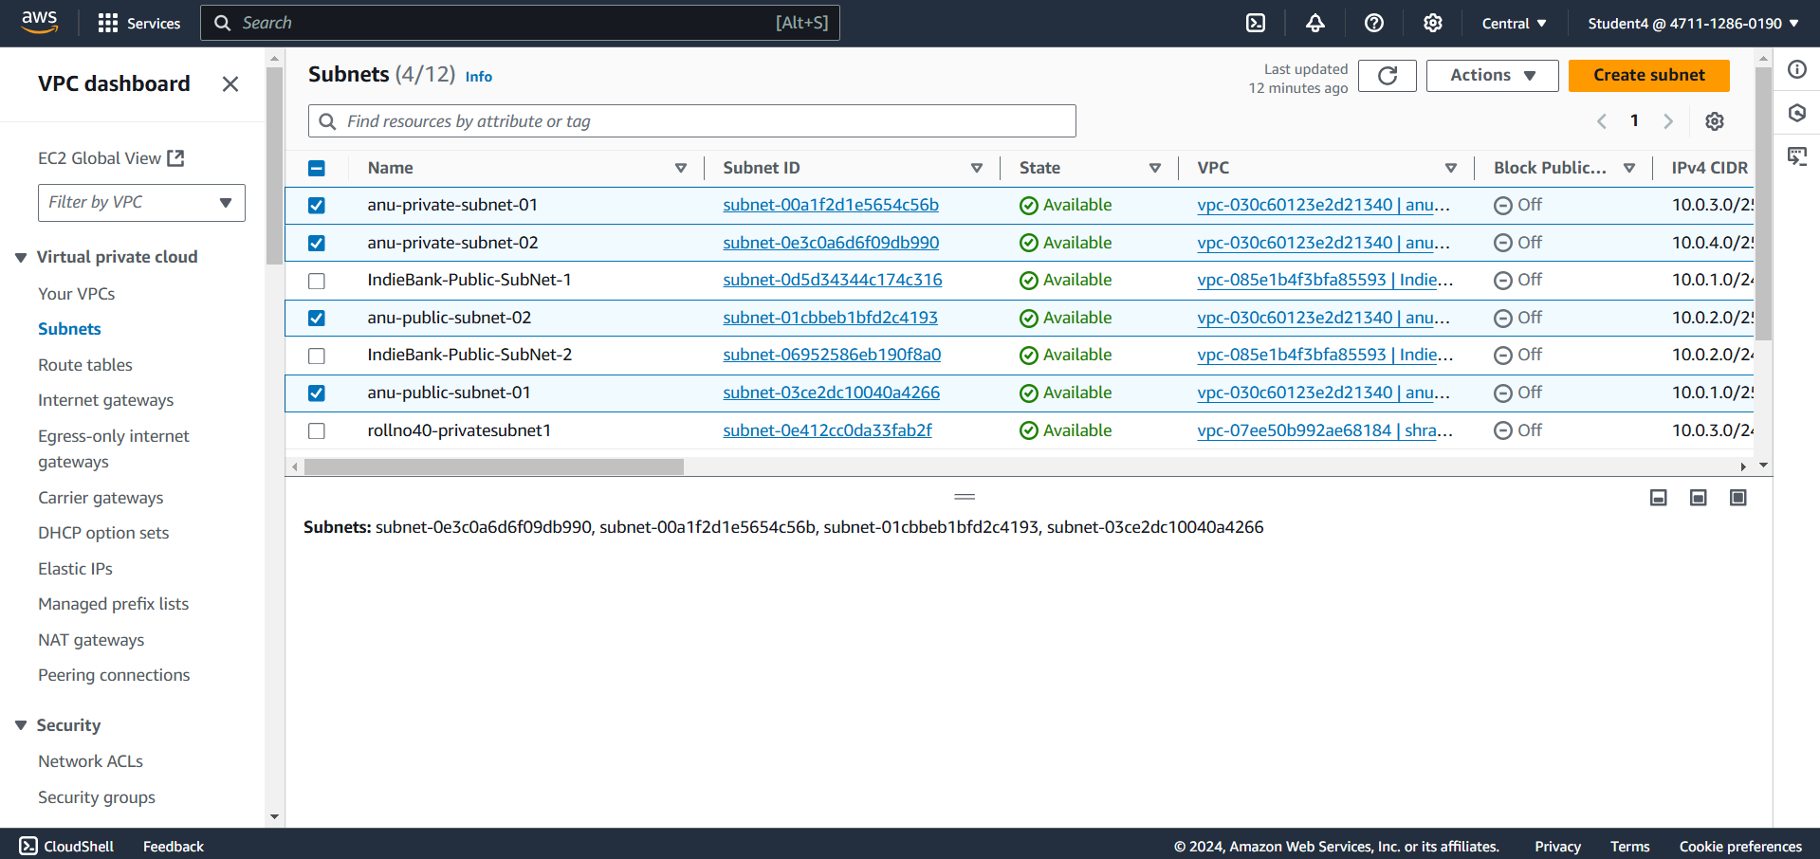

**Route tables:**

Steps:

1. To create Route table, click on create route table. We need to create two route tables that is public and private Route table.
2. In route table setting, give route tables name as anu-public-RT and anu-private-RT and select vpc that is created for both route tables.
3. Then click on create route table.
4. After route tables is created, go to routes of public Route table and click on edit route and then click on add route.
5. Then in destination, select 0.0.0.0/0 as destination and target as Internet Gateways.
6. After selecting internet gateway, it allows to select the igw- and select the internet gateway that is created by you.
7. At last click on save changes.
8. Follow same for private route table but give routes target as nat gateway that is created and click on save changes.
9. Then go to subnet association and click on edit subnet association. For public route table give public subnet as association and for private route table give as private subnets.
10. Select the subnet you have created and click on save changes.

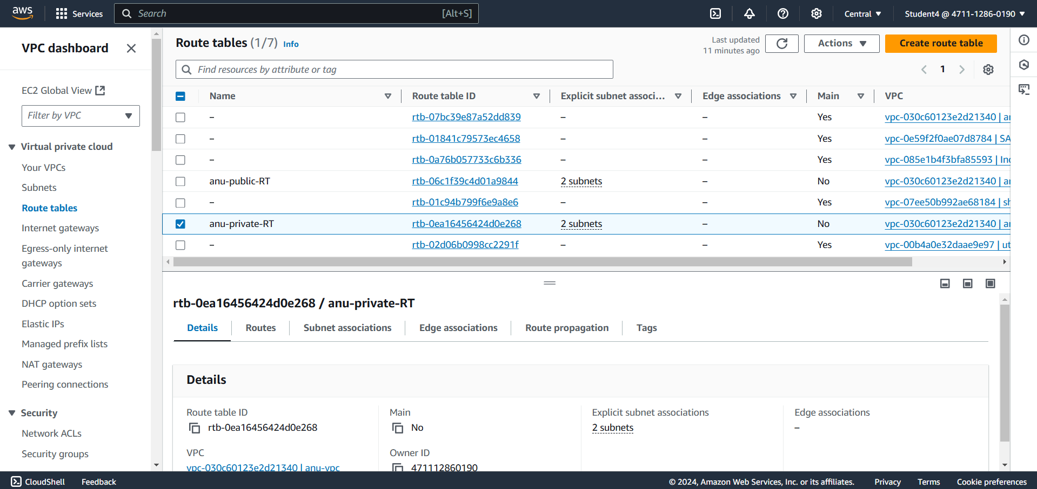

**NAT gateway:**

**Steps:**

1. Go to vpc dashboard, select NAT gateway and click on create Nat gateway.
2. After that give name as anu-natgateway and select subnet as public-subnet-01.
3. For elastic IP address, click allocate IP address and IP address is created and click on NAT gateway.

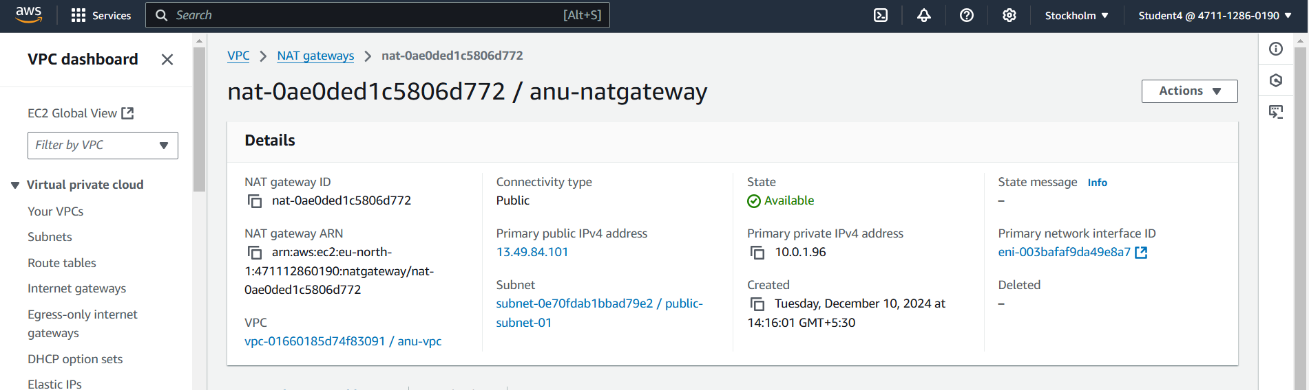

**Instance:**

**Steps:**

1. Search EC2, EC2 dashboard is opened and click on launch instances.
2. Create 3 instances that is one jump server and other two are private server.
3. Give name as anu-jump-server and other two as anu-private-server1 and anu-private-server2.
4. To create keypair, click on create new keypair. Give name as private-keypair1 for both private servers.
5. For network-setting, click on edit. Select vpc that is created and subnet as private subnet-1 and for security group, name as abc-server-SG and in Inbound Security Group Rules, select type as SSH and source type as anywhere.
6. Create two more inbound security group rules, select type as http and https and source type as anywhere for both types.
7. The configure storage should be 8 GiB and root volume as gp3.
8. Then click on launch instances. Your instances have been created.

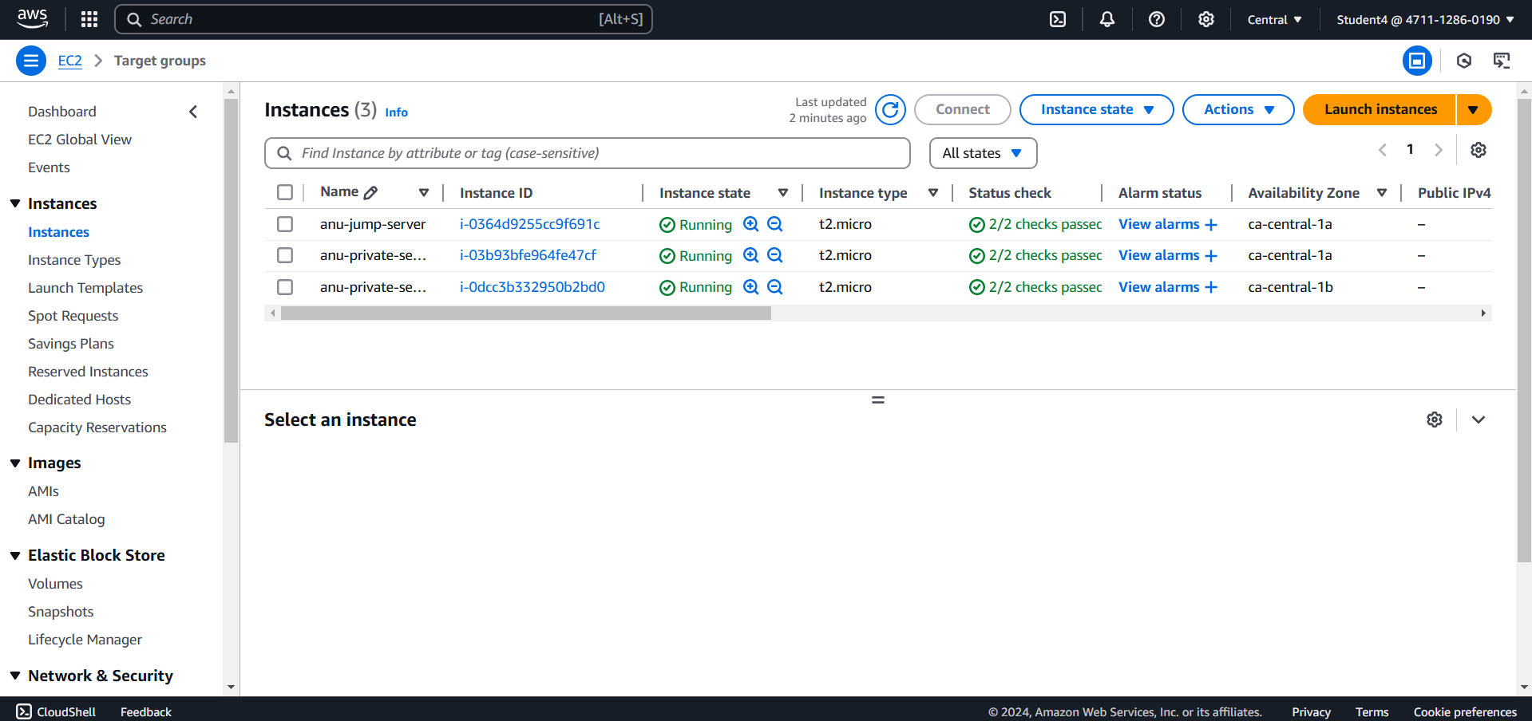

**Target group:**

**Steps:**

1. In EC2 dashboard, click on target groups and choose a target type as instance and also give name as anu-TG01.
2. Select protocol as http and select vpc that have been created.
3. Select private subnet as target group.
4. Your target group gets created.

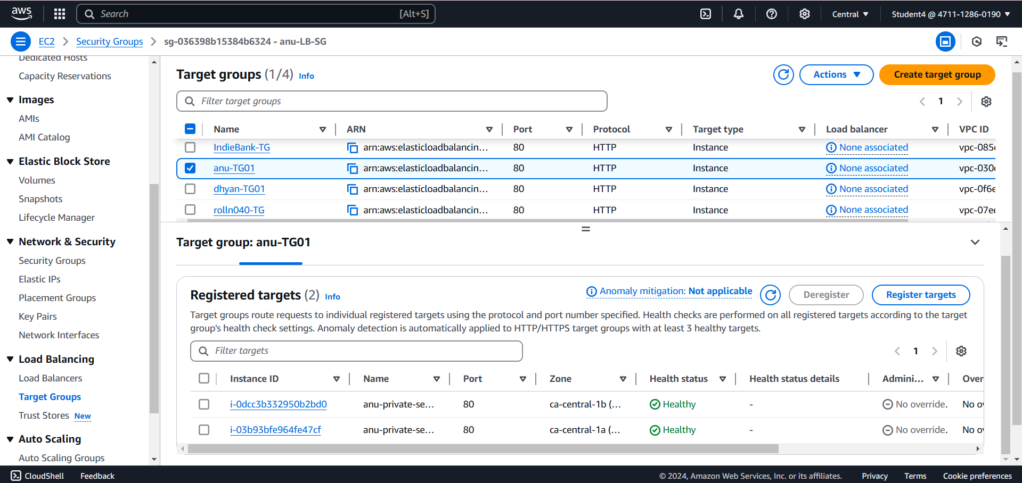

**Security Group:**

**Steps:**

1. Go to EC2 dashboard, go to security groups and give name as anu-LB-SG and give description as same as name.
2. For inbound rules, create inbounds as ssh, http and https and click on create security group.

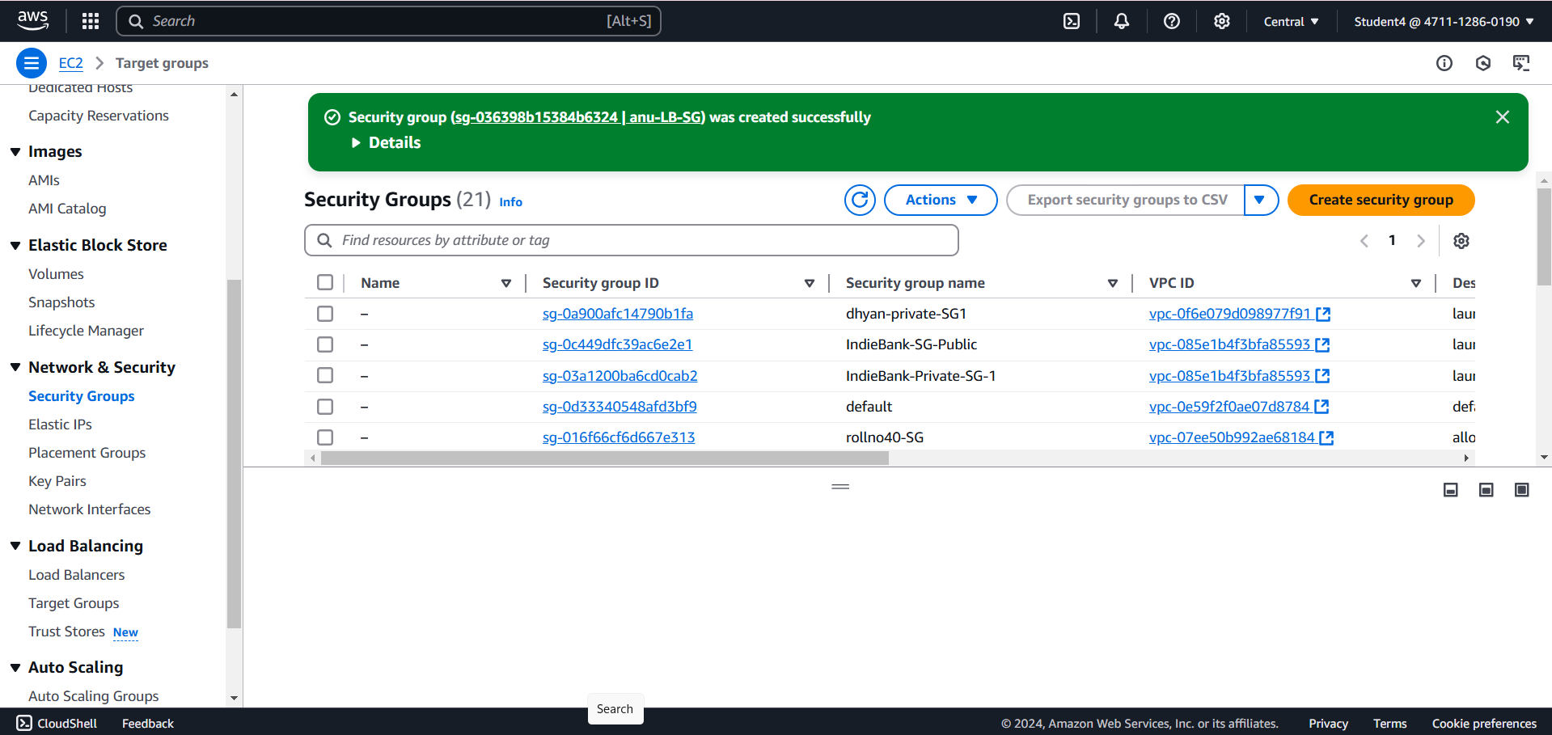

**Load Balancer:**

**Steps:**

1. Go to EC2 dashboard, click on load balancer and select application and os as window and click on create.
2. For name as Anu-LB01 and select the vpc created.
3. For availability Zone as 1a and 1b as region selected before creating the vpc.
4. Click on create load balancer.

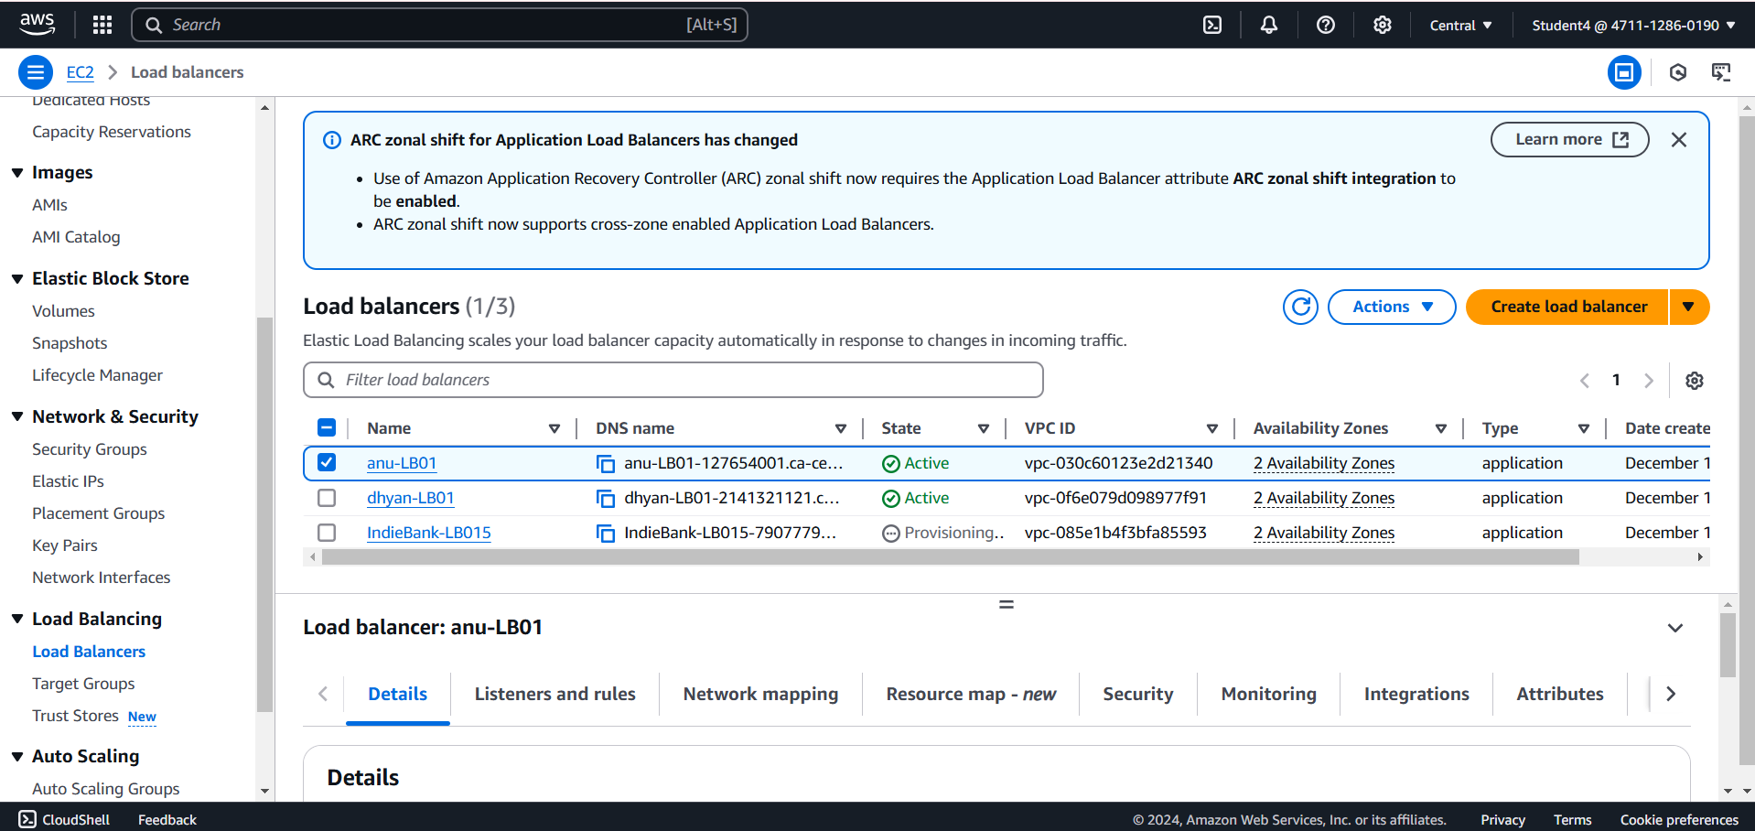

Final Result:

